Software projects 2: final report

**Group Three**

Rhiannon Kennedy

Jumana Khanom

Mohammed Meheraj

Muhammad Sohail

**Supervisor**

Sean McGrath

**GitLab Link:**

<https://gitlab.doc.gold.ac.uk/rkenn004/computingProjectTwo>

**Project Website Link:**

https://www.doc.gold.ac.uk/www/167/

Contents

1. Introduction 3

1.1 The Problem 3

1.1.1 Navigation Solutions – RHB Room Finder 3

1.1.2 Navigation Solutions – Other Universities 4

1.1.2 Navigation Solutions – Non-Academic Institutions 6

1.2 The Proposal 9

1.2.1 Minimum Viable Product One 9

1.2.2 Minimum Viable Product Two 9

1.2.3 Minimum Viable Product Three 9

1.2.4 Scenarios 10

1.3 The Team 12

2 Project Planning 14

2.1 Managing Time 14

2.1.1 Term One 14

2.1.2 Term Two 14

2.2 GitHub 15

3 System Development 16

3.1 Technology Choices 16

3.2 MVP One 17

3.2.1 Back End Development 17

3.2.2 Front End Development 20

3.3 MVP Two 21

3.3.1 Back End Development 21

3.3.2 Front End Development 23

3.4 MVP Three 24

3.4.1 Back End Development 24

3.4.2 Front End Development 26

3.5 Map Development 29

4 Testing 31

4.1 Web Testing 31

4.1.1 Web Testing Research 31

4.1.2 HTML Validator 32

4.1.3 Lighthouse 33

4.1.4 Responsive Design for Mobile Users 33

4.1.5 User Testing 37

5 Evaluation 39

5.1 Aims and Objectives Fulfilment 39

5.2 Analysis of Project Progression 40

5.3 Potential MVPs 41

5.4 Personal Reflections 42

5.4.1 Jumana Khanom 42

5.4.2 Rhiannon Kennedy 43

5.4.3 Mohammed Meheraj 44

5.4.4 Muhammad Sohail 45

6 Bibliography 46

7 Appendix A: User Questionnaires 49

8 Appendix B: Notes from weekly supervisor sessions 52

9 Appendix C: Git Commit History 57

10 Appendix D: User Guide 58

11 Appendix E: Kanban 60

12 Appendix F: UML from previous deliverable 62

# Introduction

## The Problem

The Richard Hoggart Building (RHB) is not a simple building to navigate. The upper floors especially are warren like, hallways can be cut off by large classrooms, meaning some rooms are only accessible from one staircase. There are rooms completely inaccessible for wheelchair users. This makes navigating the building quite tricky for students, staff, and visitors alike.

### Navigation Solutions – RHB Room Finder

Currently, lost students need to either use the static maps dotted around the campus or use the RHB Room Finder[1]. The static maps are useful; however, they cannot be carried around campus and there are no location-based updates. The RHB Room Finder has the benefit of being web based, allowing people to see where they need to go before they even arrive on campus, and can be accessed through mobile devices once in the building. Another useful aspect is there is a large pink marker on the map, making it noticeably clear where the room being search for is (Figure 1). This is accompanied with text instructions detailing how to get to the room (Figure 2).

|  |  |
| --- | --- |
| A close up of a map  Description automatically generated  Figure 1: RHB Room Finder. Focussed on the search and marker functions | A screen shot of a building  Description automatically generated  Figure 2: RHB Room Finder. Focussed on the text navigation. |

There are issues with this solution too. It is location agnostic - it cannot draw a path for the user on the map. It also cannot take accessibility issues into consideration, however there are pdfs with accessibility information on the page.

### Navigation Solutions – Other Universities

**University of Oxford**

|  |  |
| --- | --- |
| A screenshot of a map  Description automatically generated  Figure 3: University of Oxford searchable map. Displaying start and end of route, with options for either shortest path or step free | A map of a library  Description automatically generated  Figure 4: University of Oxford searchable map. Displaying information options once a particular building is selected. |

The University of Oxford has a searchable map. The start and end route has an autofill function as you type. Step free route option is clear. Individual buildings can be clicked on, this interaction allows users to initiate navigation. This will also bring up information about the building and includes a picture to make identification easier.

**UCL**

Figure 5: University College London map. Displaying building information

The UCL wayfinding offerings are much the same as Oxford, in that it is composed of a map that is responsive to gestures (pinch to zoom), all buildings can be selected to have a pop-up containing building information and a way to start directions.

**City, University of London**

|  |  |
| --- | --- |
| Several buildings in a row  Description automatically generated  Figure 6: City UoL navigation app, 'City Nav'. Image shows how the user can select an end point. | A screenshot of a map  Description automatically generated  Figure 7: City Nav, City UoL's navigation app. This image shows how the app displays the route to the user. |

City UoL has a campus navigation app called City Nav. Selecting a building looks easy (Figure 5) and intuitive with large pictures of each building. The route mapping is clear with both a graphic to follow and text-based instructions.

### Navigation Solutions – Non-Academic Institutions

**TfL Go**

London Underground passengers can feel anxious about getting lost, or not being able to work out where they are or where they are going [1]. In the summer of 2020, TfL introduced ‘TfL Go’, a new travel app [2]. It allows passengers to navigate the map using pinch gestures to zoom in and out. Stations and bus stops are tappable, bringing up information and the journey planner (Figure 8 ). There is an options page where a step-free journey preference can be set (Figure 9). In 2022 it won a BIMA award for its ‘bold innovative approach to digital mapping’ [3].

|  |  |
| --- | --- |
| go now button on tfl go  Figure 8: TfL Go, the start of the journey process, taken from the TfL website. | tfl go app - choose step free journey options  Figure 9: The options page of the TfL Go app, displaying the ability to go ‘step-free’. |

**V&A Museum**

The V&A Museum map allows users to use the cursor to move around and zoom in and out. Each room can be clicked on to get information about the contents of the room.

Figure 10: V&A Museum Map. Options shown are the zoom function, level selection, find a room, and current location.

Figure 11: V&A Museum Online Map. It has been zoomed in and cropped to show the interactivity.

## The Proposal

### Minimum Viable Product One

Our webapp proposes to improve upon the room finder provided by Goldsmiths. To that end the first MVP is to build a basic, text based, webapp that can take a start and finish input, then algorithmically return a route.

### Minimum Viable Product Two

The next iteration would be to introduce QR codes. These will (in theory) be placed around the RHB at useful points: the main entry points and main flash points along corridors. This will provide two functions: give students an easy access point to the service and allow for the route to be updated if a student takes a detour or gets lost.

Another addition to MVP2 is adding a GUI to the web app. This will require research to aid decision making stylistic choices, but with a client base used to apps such as Google Maps, a text-based navigation aid will not be sufficient.

### Minimum Viable Product Three

The third iteration will focus solely on accessibility. On the back end this will means making improvements to how a student can select a path. Do they require an accessible toilet? Are they unable to use stairs? Up until now whether the algorithm provides a route with either a staircase or a lift will be arbitrary, but this MVP intends to give the user a choice over the route they take.

For the front end, accessibility means ensuring the webapp conforms to standards relating to accessible web content, such as colour contrast checks.

### Scenarios

We created a storyboard of how we intend our product to work and a Venn diagram to show the different potential users of our product. This helps to see what the strengths and weaknesses of each user, which can aid in website design and considerations.

Figure 12: A storyboard showing how we intend our product to be used.

Figure 13: Venn diagram showing different potential users of our product.

## The Team

All team members are listed below. Complete with an explanation of the role assigned at the start of the project, and listed is any work they have completed for the project.

**Rhiannon Kennedy: Project Manager**

Leads the project, ensuring milestones are hit and keep track of resource allocation and planning.

* Worked on the algorithm development, which involved literature reviews of wayfinding use cases.
* Created a JSON database for the room locations.
* Turning the JSON information into a MySQL database.
* Created two Gantt charts, one for each term.
* Created and carried out a questionnaire of the existing RHB Room Finder.
* Created a Kanban board and kept it up to date.
* Wrote, and kept up to date, the logs from the term two supervisor sessions.
* Created the maps.
* Wrote much of the report.
* Completed market research.

**Jumana Khanom: Quality Assurance Manager**

Oversees the testing process, making sure the right testing practices are in place and results are learned from / implemented.

* Researched, and documented, a review of existing campus navigation solutions.
* Developed the front-end web, with a particular focus on the styling.
* Researched web accessibility best practice and implemented based on these findings.
* Carried out testing of the webpages created.
* Kept personal tasks up to date on the Kanban board.
* Contributed to the potential future MVPs.

**Mohammed Meheraj: Lead Developer**

Responsible for the technical development of the website, including coding and feature implementation.

* Completed a set of wireframes for the webapp GUI.
* Completed the proposed class diagrams.
* Contributed to the potential MVPs, completing research on maps and vectors.

**Muhammad Sohail: UI & UX Lead**

Focus on the usability and design of the final product.

* Completed a set of wireframes for the webapp GUI.
* Kept personal tasks up to date on the Trello/Kanban board.
* Contributed to the Web testing phase.
* Contributed to the research and making of the QR code/s.
* Aided in completing parts of the report through text and images.

# Project Planning

## Managing Time

### Term One

In the first half of the project, we decided on using a Gantt chart in conjunction with Agile. There was little familiarity within the team to Agile until it was introduced at the start of the module. We decided on this approach as completing work in short 2-week chunks was appealing as it meant there should have been constant check ins with how everyone is progressing and a level of flexibility if a task was finished sooner / taking longer than originally expected.

In practice this did not work as well as anticipated. Meetings that were planning were poorly attended so putting Agile techniques into practice was impossible. Once the Gantt chart was made it was rarely (if ever) referred to.

### Term Two

The team felt that the planning for term two could be more successful than term one. Two solutions were thought up: a simpler Gantt chart (Figure 14) to be used as an overview so members could see how the various aspects of the project are coming along; the second was to use Kanban boards for the granular tasks. The intention was to allow everyone to get an overview of how the project is progressing in the Gantt, but individual tasks could be set (and kept track of by the whole team) using Kanban. Another change in term two are the weekly ten-minute supervisor meetings with Sean (minutes available at Appendix B).In the absence of regular team meetings, the Friday morning supervisor sessions was generally when the tasks were updated.

Figure 14: Gantt Chart for term two.

## GitHub

To facilitate easy multi-user coding, the team needed a version control system. This would help all team members keep track of how the project is progressing. It was important we could see the changes made to the code. Git was chosen because it is the most popular version control system [4]. Our commit history can be seen at Appendix C.

# System Development

## Technology Choices

Initially we chose to use Node.JS for the web, JSON for the data, and JavaScript for the programming. We chose this because the team were familiar with these technologies, due to the ‘Dynamic Web Applications’ module we were all taking concurrently with this project. It was felt by term two, when the actual coding of this project was taking place, the team would be able to take on this project with some knowledge and confidence. With the algorithm being coded in JavaScript and the web being based on Node.JS meant good interoperability. Using JSON made sense to complete the tech stack because it is derived from JavaScript [5]. However, as is explained in the next section, a decision was made to change it to a LAMP stack.

**Linux**

Linux is the market leader in web hosting, with 41.3% [6] of all known websites using it. It’s open source and (for many distros) free. Ubuntu is regularly patched, and we have used a ‘Long Term Support’ (LTS) release, which receive 5 years of maintenance [7]. Perhaps the most compellingly, Computer Science students get free access to a Linux Ubuntu VM. Having a web server hosted and maintained by the University free of charge was a practical decision. This also means that the installation and setup is largely done for you so the website could get up and running pretty quickly.

**Apache**

The decision to change to PHP was made first, then Apache was chosen over Nginx because the LAMP stack is well documented and proven [8]. Like Linux, there is a robust community to support Apache, and a third of the internet runs on it [9].

**MySQL**

The move from a non-relational data model to a relational database (in this case, JSON to MySQL), was due to many the benefits a RDBS has. MySQL allows for improved data integrity using tables and foreign keys.

**PHP**

PHP’s extensive compatibility with MySQL was very appealing when it came to choosing this element of the tech stack. PHP makes it easy to connect to, and query, data from a MySQL database.

## MVP One

### Back End Development

Initially, we looked at both Dijkstra’s and A* algorithms. Both are used to find a path between two points, with A* having the addition of heuristics to aid efficient path navigation. A benefit of A* over Dijkstra’s is that it has been found to perform quicker, although the paths both algorithms generate are the same length [10]. The pseudocode for A* is freely available [11] and was used as a launchpad. The first task was to code this pseudocode into JavaScript and make it functional with a basic test, printing results to the console.

Two functions were set out in the pseudocode: aStar (taking: start, goal, heuristicCostEstimate and nodeGraph as parameters) and reconstructPath (taking nodeAncestors and currentNode as parameters). The aStar function is entirely a while loop that will iterate through neighbouring nodes that it has not evaluated yet, judge if that node will provide a short path to the goal and continue until the goal node has been found. Once the goal node has been found, the reconstructPath function is called and prints the path to the user.

Once the pseudocode had been implemented in JavaScript, tests were carried out. Dummy data was created – four nodes in a straight line, with the heuristic estimate given, and a test to see if it could get from A to D. Figure 15 shows the console log test. This resulted in the terminal hanging.

Figure 15: Console log test of the A* algorithm. It shows a graph of four nodes in a straight line and the heuristic estimate hardcoded.

To work out where the program was failing, and what the issue might be, more console logs were created throughout the code to show the progress of the algorithm iterating through the nodes. At first console logs were put it the aStar function as it was the most complicated part of the code as thus the likely flashpoint. However, as can be seen from Figure 16, this completed as expected.

Figure 16: Section of console log output from the aStar function. A middle loop can be seen evaluating to neighbour nodes.

The next section to test was the reconstruct function. This function gets called once the A* algorithm finds and returns a path. Before testing the function itself, a console log was entered right at the start of the function, to confirm the function is being called correctly. It became evident that the root of the hanging issue was here. The console returned a stack overflow error after attempting to begin the reconstruct path function 679 times. The fix was to prevent nodes being re-evaluated (Figure 17).

Figure 17: Code added to A* function loop to ignore evaluated nodes

Now the algorithm works with basic input, the next step is to expand the data structure. Starting with some of the intended locations for the QR codes (Figure 18) made sense because there are a small number of them compared to the rooms, and because being able to navigate between QR code locations is the minimum this project should be able to do.

Figure 18: Snippet of JSON scheme. Showing location and paths.

There were issues with the integration of the JSON file with main.js. To debug this a very verbose console log was created in main.js to print out the contents of the data, to assess whether the JavaScript could read the file as intended. This was successful, but after spending quite some time trying to implement the A* algorithm Sean suggested making some changes which will result dropping A* for Dijkstra’s.

The change in algorithms also brought along a change in the tech stack. The move to LAMP has been explained in **Technology Choices**.

For the first MVP we stuck to hardcoded data in an array, opting to skip JSON to implement MySQL in the next MVP. The use of the hardcoded data in conjunction with PHP can be seen in Figure 19.

Figure 19: PHP code to fill in room name into from box if the room number appears in URL.

### Front End Development

HTML was used at first to create a simple foundation webpage that had a search function for finding different rooms, a box where the maps will go once made up, and some buttons to interact with (zoom in/out, pdf download, and a link to campus information on Goldsmith’s website). This replicated what we have seen when researching the methods employed by other Universities. The wireframes made in term one lacked specificity, so we did not have much to go off from.

When considering readability and accessibility [12], the sans serif font ‘Arial’ was our font of choice. It has been proven to be good on websites for individuals with poor eyesight [13] and dyslexia [14]. The search bar was placed at the top because it needs to be ‘visible and readily available’ [15].

Only essential buttons were included, this is in recognition of the prevalence of mobile device use where an excess of buttons could be intrusive. For this reason, these were placed on the right-hand side to enable most of our users – right-handed mobile device users – to use our product efficiently. The zoom function itself is important because it will help users to view the map in the level of detail they require. The buttons have rounded edges for aesthetic as well as practical reasons. From a usability aspect they reduced the risk of accidental clicks, enhancing user-centred interaction, easier to recognise and click on for those with motor impairments. Aesthetically, they help create a pleasant user experience because of their ‘softer and more visually appealing look [16].

## MVP Two

### Back End Development

The second proposed MVP is to implement QR codes. The free QR code generator from Adobe[2] was used to create Figure 20.

Figure 20: Working QR Code that points to <https://www.doc.gold.ac.uk/www/167/index.php?from_room=000>

To prove the concept works, only one QR code was generated for the main entrance. The PHP logic was adjusted to look for a room number in the URL, if it was present (it would be if directed from QR code), then the from room drop down box would be filled in. Leaving the ‘to’ room drop down box for the user to fill in.

A MySQL database was created at this time (Figure 21) and the code was updated to query the database.

Figure 21: ERD of first iteration of the MySQL database.

Figure 22: PHP code querying the MySQL database to retrieve rooms for the 'From Room' dropdown box.

### Front End Development

To begin to integrate the homepage with the inputs and outputs from the PHP, the search bar was changed to a webform allowing a start and end location to be entered and submitted. Colours were added to make the design more visually appealing. There were issues with the zoom function – the width of the green box would grow to be the point it came of the screen. On advice from Sean, CSS was used instead of JavaScript due to its efficacy in border manipulation and scaling.

Figure 23: Second iteration of the homepage.

## MVP Three

The third MVP is to take accessibility issues into consideration.

### Back End Development

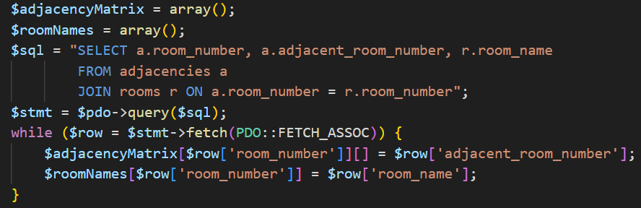To facilitate accessibility options, development of the route page of the website was required. Up until now the route displayed room numbers. This is fine for the classrooms; however, all other entries had a code that wouldn’t mean anything to users (stairs are a three-digit code beginning with 4, lifts 5). The SQL query now (Figure 24) has aliases for the rooms and adjacencies tables, allowing the room name from the ‘rooms’ table to be combined with the room number from the adjacencies table. This change has made clear an issue with the route making (Figure 25). Stairs and lifts are treated identically to rooms in the database, they have adjacencies but across multiple floors to facilitate level changes. Due to this formatting, it is unclear if users are expected to walk up/down the stairs, or merely walk past them.

Figure 24: Updated SQL query. This query also pulls the room name, allowing it to be used in the route.

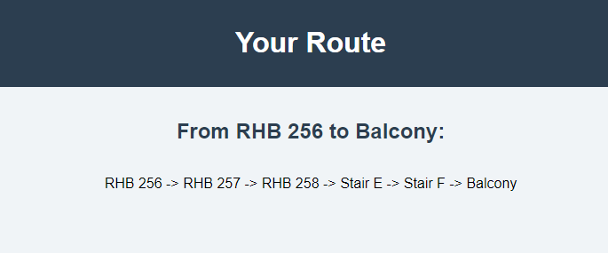

Figure 25: Route page of the website. Showing the lack of clarity with the stairs - is the user expected to walk past them or use them?

The toilets have their own table, to allow the accessibility to be noted. Unfortunately, we were unable to utilise this in the code to allow users to pick accessibility as an option.

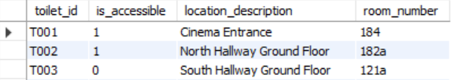

Figure 26: Section of the 'toilets' table, showing it distinguishes between accessible and non-accessible toilets.

The opportunity was also taken to increase the security of the code. The website is potentially vulnerable to Cross-Site Scripting (XSS), a method of hacking where a malicious actor can inject code into the client’s browser [17]. Adding htmlspecialchars() when taking data from the form and convert into HTML, thereby preventing such attacks.

Error handling was added to database_connection.php (Figure 27), if the PDO fails, an exception should be thrown [18]. Another example has been added to process_form.php (Figure 28) is to ensure the adjacency matrix has been correctly filled before passing the inputs to the Dijkstra’s function.

Figure 27: Snippet of database_connection.php showing error handling in case of a failed connection.

Figure 28: Checks the adjacency matrix has been filled properly before passing inputs to Dijkstra’s.

### Front End Development

For this phase of the website development, extensive use of accessiblity testing was employed to improve on the existing design. The WCAG guidelines outline contrast ratio requirements [19] which we adhered to to improve readability among indiviuals with visual impairments. Other tools such as Colour Safe [20], Accessible Colours [21], and design recommendation from the RNIB [22] were also employed to validate colour choices. The result of this research can be seen in Figure 24. The background is a light and neutral colour, fostering a comfirtable reading experience by providing a good contrast with the text colour. The green border was carefully chosen to create a noticeable contrast against the background without overpowering the content. This decision enhances the visibility of the content and promotes a balanced visual experience. For buttons and inputs, a Dodger blue background with white text was chosen, again for the purposes of facilitating easy readability.

Figure 29: Third iteration of the homepage.

The ‘Colour Contrast Checker’[3] was used to validate our choice of colour. Figure 27 shows the first attempt failed the WCAG standards. Figure 26 shows the second attempt passed to an AAA standard. Figure 25 shows the choice for the title bar also passes these guidelines to a triple A standard.

Now there was a set of maps that could be imported, it was noticed that the zoom function was not as smooth as it could be. To improve this, the ‘transform’ property in CSS was utilised.

Figure 30: The colour choice for the title bar passes the guidelines to a triple A standard.

Figure 31: The second attempt passed to a triple A standard.

Figure 32: The first choice of colour for the border failed the WCAG Accessibility Guidelines.

## Map Development

The map design was an area we felt we could improve upon. Before producing our own designs, we wanted to find out what Goldsmith’s student felt about the current map used by the RHB Room Finder. As this process started later in the project than planned, expediency was key. A closed, quantitative approach was chosen because it would give us two benefits: it would take students the least amount of time to do and therefore the response rate should be higher compared to, for example, meeting a small group in person at the same time; and a good response rate would give a broad strokes overview of what could be improved upon (if anything at all). The questionnaire received 12 responses, which can be viewed in brief at Table 1 and in full at Appendix A. The questionnaire was completed using Google Forms. No personal data (including email addresses) was collected as it was deemed unnecessary because there would not need to be a follow up with these specific respondents.

Table 1: Table shows the percentage values of the responses given to a questionnaire about the RHB Room Finder Map

The most striking trends are that students generally find the existing map both easy to understand and felt they could use the map to navigate the campus (66.7% and 75% respectively). However, 66.7% of respondents felt it could be made clearer. The outlier are the responses to the question “Would you like to see changes to the map?”, with a large minority (41.7%) saying “maybe”. There are a few possible reasons for this: it was the last question so perhaps respondents were fatigued, it could be a genuine response because they feel they are unlikely to use it often and it does the job adequately enough, or lastly, it’s just a badly worded question and as such got the response it deserved.

Figure 33: Final design of second floor map.

An example of the design can be seen in Figure 28. The room types have been colour coded so at a glance stairs, toilets, and student areas can be seen. Rooms that are staff only are in grey and have no room number so it does not distract from the places students will need to go to. Stairs and lifts are not labelled to reduce clutter, and this will not reduce functionality because the correct stairway/lift can be highlighted on route*.*

Adobe Colour Accessible Tools were used to ensure the maps are legible to those with impaired vision. Figure 32 shows that the first set of colours were not accessible, changes were made, and it passed in Figure 33.

|  |  |
| --- | --- |
| A screenshot of a color palette  Description automatically generated  Figure 34: Adobe Colour Accessible Tools showing the original map colours were not colour blind accessible. | A screenshot of a color palette  Description automatically generated  Figure 35: Adobe Colour Accessible Tools showing the map colour scheme can be distinguished by colour blind individuals. |

# Testing

## Web Testing

### Web Testing Research

A list of web testing was made to ensure that with each testing phase we are able to mitigate risks, identify and rectify potential issues and deliver a high-quality website that meets user expectations and fulfils its’ intended purpose effectively. The full list can be seen in Figure 31.

Figure 36: List of potential tests to be carried out throughout the duration of this project.

### HTML Validator

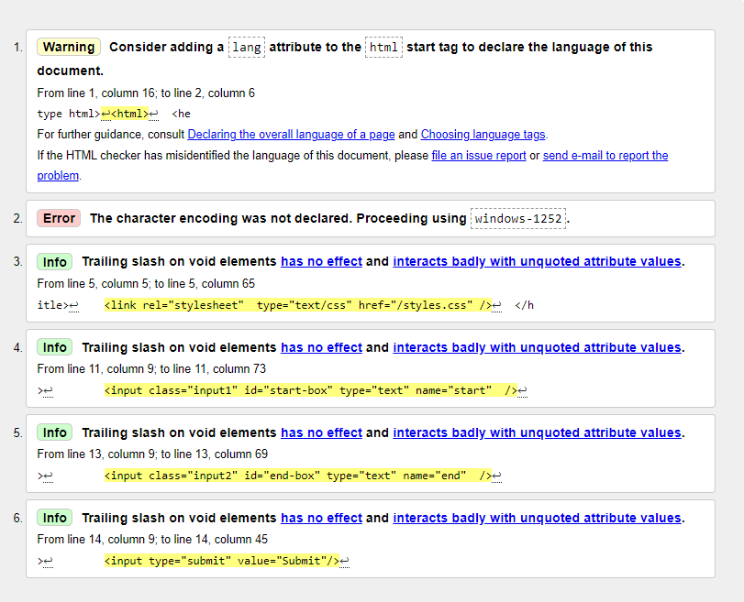Web testing tools were used throughout development. The HTML Checker[4] was used multiple times to validate our progress, as can be seen in Figure 32.

Figure 37: Early HTML Validation test of the homepage.

### Lighthouse

The Lighthouse tool that comes with the Google Chrome browser runs an audit of a website, checking performance, accessibility, best practices, and SEO [23]. As can be seen from Figure 36 the website performs well, however because it is such a lightweight webpage this is to be expected.

Figure 38: Early Lighthouse test of our homepage.

### Responsive Design for Mobile Users

This app will predominately be used by mobile users; therefore, it is paramount that the user experience on a mobile device is good. Using the ‘Responsinator’[5] tool, which can give desktop users an indication of what a website looks like on smaller screens, it became apparent there was an issue (Figure 37).

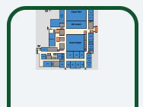

Figure 39: Testing the webpage for mobile devices using the Responsinator.

The CSS was adjusted so the height values were relevant to the viewport, instead of a defined pixel size.

When the webpage was first seen on a mobile phone (Figure 38), it was clear that the design could be much improved for smaller screens. A media query was added (Figure 39). The maximum width was set to 768px, a typical size for phones [24]. Other adjustments made were to the margins and positioning of the elements within the webpage. Instead of fixing these elements by pixels, viewport was used so it could adapt better to different screen sizes. Figure 40 and Figure 41 shows the result of these changes.

Figure 40: First look at the webpage on a mobile device. Shows that it is not yet a responsive design.

Figure 41: Media Query within the code to allow the browser to display the elements as intended by different screen sizes.

|  |  |
| --- | --- |
| Figure 42: Top half of webpage on a mobile device. | Figure 43: Bottom half of webpage from mobile device. |

The Next steps were to make the images and border more responsive on phone [25] but due to lack of timing there wasn’t any space in the schedule to complete those tasks.

### User Testing

considerable

acceptable

partially Bad

fantastic

Really Bad

Figure 44: Pie Chart of user testing results.

insubstantial

Moderate accessibility

Really accessible

Good accessibility

Poor accessibility

Figure 45: Pie Chart of user testing results.

Through user testing of the website, the majority expressed that, design-wise, the colours were deemed "unappealing" and "simple." Users also noted that the selection of different colours did not seem cohesive or make sense. Functionality wise the users have asked for some way to display various locations for when entering their start and end location as they may not remember the full name of the building that they want to go to.

Taking all this feedback into consideration, some changes have been implemented. First the addition of a border that’s like the ones in the pre-existing designs and changed the colours a bit so that it can provide a good contrast between text and background elements, making them more readable for users with poor eyesight and they also benefit users who browse in low-light conditions, such as at night or in dimly lit rooms. Dark backgrounds reduce the amount of light emitted by the screen, which can decrease eye strain and improve readability [26]. Overall, “Many users find dark mode more visually appealing” which has encouraged us to create a darker themed campus map so that it can enrich the users' experience.

# Evaluation

## Aims and Objectives Fulfilment

The main stated aim we gave ourselves at the start of the project (as seen in our first deliverable) was to make navigating the campus easier. The original scope was to create an app that works for the entire campus. This was very ambitious, and by the end of term one this was curtailed to just the RHB. We gave ourselves three objectives:

**Efficient campus navigation**

This objective was completed with some success, however there is room for improvement. The navigation does work, in that it will get a user from A to B, however the way the level changes have been written into the database there are many instances where both the lift and staircase make up the route.

**Comprehensive building information**

This objective was successful. The maps clearly show the places students will want to go – classrooms, services such as the shop, and toilets. To aid comprehension and reduce clutter the lift and stairs labels included on the RHB Room Finder were omitted. This could be improved in further iterations by having two versions of the map: one on the homepage with its colour coded design, and another used by the route display where all rooms are in a neutral tone and the start and end rooms made clear in a different colour.

**User-Centred Design**

Through our font choices and the introduction of coloured maps should mean our webapp is accessible to a broad range of students. Web accessibility tools have been used extensively to show our product can be used by those with visual impairments. However, this objective does fall short of having a step free access option. This really causes issues where there is a floor change in the route. Both lift and stair access are distinguished in the database, but we were unable to implement this in the code due to running out of time. This means we cannot offer that option yet.

## Analysis of Project Progression

The project progression was often slow and frustrating. The team took a while to get together a decide on what the project will be, and the first two deliverables were rushed. Team meetings were set and agreed on by all team members, but attendance was not satisfactory. All four team members did not spend any time whatsoever in the same room to discuss this project in the 20 weeks spent completing this module.

In conclusion, there is much to be learned from here in terms of team and project development. Some team members had to adapt their tasks to ensure the project stayed on schedule, but the capability of the webapp was curtailed due to the team hours being dedicated to this module.

The introduction of Kanban was beneficial but not used to its full potential (Appendix D, Figure 45). Just three categories were used (backlog, in progress, done). In future, creating more groups for each section of the project (research, report, coding, web) will make it easier to see which areas are doing well and which need more focus. Some of the existing tasks have been moved to show how this may have been done better (Appendix D, Figure 46).

There was some implementation of Agile techniques in term two. The structure of the MVP progressions helped the team to utilise the technique by breaking down the coding sections into smaller bites to work on week by week. This could have been improved by having weekly in person meetings to establish the weekly tasks better, instead of getting a list on the Teams group chat which were not always read. This also would have allowed the team to police each other better when it came to task completion.

The change of approach to the back end is an example of using the double diamond approach to design. We built something, it didn’t quite work, so a change of strategy to get to the same goal to allow a better design to be built.

## Potential MVPs

There are numerous ways this webapp can be improved upon in future iterations.

**Potential MVP Four**

Rather than, or in addition to, the dropdown boxes for users to input start and end locations, it could be preferable to allow them to use the map to tap in these inputs. It would involve adding the XY co-ordinates of the rooms on the map to the database for this alternative to work.

Another way of utilising the maps more effectively would be to draw a series of arrows once the route has been found. This would mean building upon the data used in the suggestion above.

This could be done through recreating the maps completely in code. Using SVG would enable us to create layers in the map. Layer 1 could be the basic outline of the building and rooms, then additional layers could be added on top to highlight certain rooms and corridors based on user input.

**Potential MVP Five**

Dark and light themes for apps and websites are commonplace nowadays, to the point it is often as expected feature.

**Potential MVP Six and beyond**

Expansion to the rest of the campus. An efficient flow for these MVPs would be to complete one building in isolation, like we have for the RHB, then integrate with the RHB.

Exploring the use of cookies and accounts could enable functionality such as allowing users to save favourite locations for faster access.

In the current iteration of the program only the lettered stairs are used. The other staircases could be added. This would improve the flow of the building because bottlenecks would be reduced.

## Personal Reflections

### Jumana Khanom

Personally, I felt that that project went a little slower than I anticipated and that what held me back from finishing my part of the project in time was not the amount of time, but the lack of work that some people did in this project which contributed into me not being able to create the website as to how I fully envisioned it to be, I felt as though most of the work had to be done by me and my team mate Rhiannon Kennedy so there was a lot of pressure to get the work done and to complete other people's tasks that were either incomplete or insubstantial. For example, the high-fidelity wireframe was really lack-Laster so I had to go off other pre-existing designs that could help me with the design portion of the website. This experience has helped me expand my proficiency in navigating unforeseen circumstances and helped me find creative solutions. Furthermore, what slowed me down even more was that I recently found out that I had a heart condition which really worried me and prevented me from putting my thoughts coherently and concisely on paper. In terms of project development, I learned the importance of effective collaboration and communication within a team. The issue of some team members not contributing as expected became a hindrance, impacting the overall progress. Moving forward, I recognize the need for clearer project roles, expectations, and regular check-ins to ensure everyone is on the same page and contributing appropriately. This experience highlighted the significance of proactive problem-solving and team management in achieving project goals, combatting unexpected problems, and adapting when things do not go the way that it is supposed to. Additionally, the revelation of my heart condition presented a personal challenge during the project. It taught me the importance of resilience and adaptability in the face of unexpected personal challenges. While it did affect my ability to articulate thoughts coherently at times, it also reinforced the need for effective time management and prioritization.

During the design and coding phase of the project I couldn’t make the images or the border responsive and I wasn’t able to switch between images when the user entered their start and end location because I was struggling on figuring out how to make the border and images responsive on mobile as it looked responsive on website. However, if I had more time, I would make a dedicated list of what things I need to get done first, depending on the priority of each task so that even if one task is only semi-complete, I know that I at least have something than nothing. Furthermore, In the last 2 weeks of the project , I was able to use git to record the changes of the code, the reason it looked like I haven’t been working on the project was because I didn’t know how to use it until the last 2 weeks of the project and that fault was on my part because I didn’t ask and that’s why my commit bar is so low.

In summary, this project provided not only technical knowledge and skills but also insights into effective project management, collaboration, and personal resilience. It serves as a valuable learning experience that will inform my approach to future projects, with an emphasis on fostering a positive and productive team dynamic.

### Rhiannon Kennedy

I was made project manager, a role I had my doubts taking on as I have little experience in leadership roles or running a project of this size with others. However, I took it on both because it seemed a good chance at developing these skills and no one else expressed an interest in this role.

Reading academic literature was an area I had limited knowledge of, but I now have good foundational knowledge on how to read and understanding this style of text. I also had the opportunity to get in contact with the subject librarian for our department, Caitlin Moore. The meeting was very useful, giving me hints on how to find and make the most of the online resources available to us.

This project was chosen because it played to the team’s strengths and knowledge from previous modules, particularly JavaScript and web dev. Over the course of this project my knowledge of JS and web dev has grown, as well as new tech such as PHP. Coding the logic behind the website has been stressful and rewarding in equal measures. Through making the maps I got the chance to make use of our free access to the Adobe Suite. This has given me the confidence to ‘push the boat out’ further when it comes to my final year project.

I doubt my leadership skills have much improved, I repeatedly struggled to keep team members engaged and on point. Once it was clear that a lot of chasing up would be required, I instead opted to take on the work myself. I did try to lead by example, when we agreed in-person meetings weren’t worth the bother of trying to set up (due to low attendance), we agreed instead to increase the level of ‘chat’ on MS Teams, with members showing each other what they were working on etc. I didn’t enforce this well and the group MS Teams chat is generally one sided.

In conclusion, I will be taking most of the skills I have developed throughout the duration of this module and using them extensively in my final year project and beyond. Despite the frustrations I had completing this project, I have enjoyed it and I intend to develop it further.

### Mohammed Meheraj

From previous modules, I have learned about the skills needed to create software but was able to put this into effect for the project. Looking back at the prior assignments, I believed this would be a difficult task as there were so many ways of implementing the map and because of the timeframe it would be difficult to implement certain methods without facing issues.

Because of the software being web dev and JavaScript, it was much better because to make the software we could use knowledge that we just learned, as we all learned about coding in JavaScript and html quite recently. However, because we only learned this knowledge recently it means our experience was put to the test and would have made more mistakes than someone more advanced.

There were many ways to execute this software and the ways that were shown weren't all the possible methods of doing so. I feel as though I could have gone more in depth to show all possible methods, with benefits and drawbacks as to why it would be a viable option. Doing this helped with my view of a problem as there were so many ways to execute that we could've implemented.

If we were to redo this, I would have like to be more involved with the project but there were certain constraints which were holding me back. I think overall the project is great and would like to keep working on it in the future but would need to keep testing other potential MVPs to see how other methods would work out for this specific project.

### Muhammad Sohail

Overall, I believe that this project has gone well but could have been better. I was made the UI/UX Lead which ultimately meant that I had to make sure the consumer was given the best online experience and due to this I had to do the tasks that made the app easier to use for consumers and it has the least bugs as possible. As a result, I was given tasks such as to create QR codes along with research on them and create lists of tests I can carry out with the code that has been implemented and improve the code accordingly if the app had failed anywhere.

Along with tasks such as the ones mentioned, as a group we had to contribute to the developing of the web app which proved to be a bigger challenge than I had already anticipated not only because the languages we were using e.g. JavaScript was new to us but at the start of the year I had run into family and health issues which resulted in a heavy toll in my university project/s and my communication in the group had sparked to an all-time low and hence wasn’t able to push as much in university as a whole and work on the code as I would have expected to . I still managed to complete majority of the tasks that were given even though they were a bit later than expected. However, I do believe that due to the in-experience and small knowledge I had; the coding tasks proved to be harder than originally anticipated.

If in the future, we do have to continue this project or do something similar on a longer time period deadline where I am able to take crash courses to gain experience on the coding languages, I would definitely be more involved in the project and if issues outside of university do occur, not let them take a big toll on me as they have this year thus far.

# Bibliography

|  |  |
| --- | --- |
| [1] | J. Kim and O. Gustafson-Pearce, “Passengers' anxiety about using the London Underground,” in *IEEE International Conference on Intelligent Rail Transportation (ICIRT)*, Birmingham, UK, 2016. |
| [2] | Transport for London, “New TfL app to help Londoners plan ahead and travel safely,” 04 August 2020. [Online]. Available: https://tfl.gov.uk/info-for/media/press-releases/2020/august/new-tfl-app-to-help-londoners-plan-ahead-and-travel-safely. [Accessed March 2024]. |
| [3] | British Interactive Media Association, “BIMA Awards 2022 - TfL Go,” [Online]. Available: https://bima.co.uk/tfl-go-a-new-travel-app-for-london-tfl-digital-transport-for-london/. [Accessed March 2024]. |
| [4] | Stack Overflow, “Stack Overflow Insights: Developer Survey 2018 Results,” March 2018. [Online]. Available: https://insights.stackoverflow.com/survey/2018/#work-_-version-control. [Accessed March 2024]. |
| [5] | “What is JSON?,” W3Schools, [Online]. Available: https://www.w3schools.com/whatis/whatis_json.asp. [Accessed February 2024]. |
| [6] | “W3Techs - Comparison of the usage statistics of Linux vs. Windows for websites,” W3Techs , [Online]. Available: https://w3techs.com/technologies/comparison/os-linux,os-windows. [Accessed March 2024]. |
| [7] | “Ubuntu Release Cycle,” [Online]. Available: https://ubuntu.com/about/release-cycle. [Accessed March 2024]. |
| [8] | “AWS: What is a LAMP Stack?,” [Online]. Available: https://aws.amazon.com/what-is/lamp-stack/. [Accessed March 2024]. |
| [9] | W3Techs, “Usage statistics of Apache,” [Online]. Available: https://w3techs.com/technologies/details/ws-apache. [Accessed March 2024]. |
| [10] | A. Goyal, P. Mogha, R. Luthra and N. Sangwan, “Path Finding: A* or Dijkstra's?,” *International Journal in IT & Engineering,* vol. 2, pp. 1-15, 2014. |
| [11] | “A* search algorithm,” Wikipedia, 2024. [Online]. Available: https://en.wikipedia.org/wiki/A*_search_algorithm#Pseudocode. [Accessed 29 02 2024]. |
| [12] | “How to choose a font for accessibility,” Siteimprove, [Online]. Available: https://www.siteimprove.com/glossary/accessible-fonts/#:~:text=The%20most%20accessible%20fonts%20are,rather%20than%20the%20body%20text.. |
| [13] | S. V., “Font Readability Research: Key Difference Between Serif Vs Sans Serif Font,” *Sofiia V.,* no. What About Guys With Poor Eyesight?, 2021. |
| [14] | “ Dyslexia friendly style guide,” British Dyslexia Association, [Online]. Available: https://www.bdadyslexia.org.uk/advice/employers/creating-a-dyslexia-friendly-workplace/dyslexia-friendly-style-guide. |
| [15] | J. Juviler, “Search Bar Design: How to Design for Your Website,” 5 january 2024. [Online]. Available: https://blog.hubspot.com/website/search-bar-design. |
| [16] | I. U. Baig, “Comparing the Aesthetics of Rounded and Rectangular Buttons,” Medium.com, 2023. [Online]. Available: https://tinyurl.com/53kj3prf. |
| [17] | L. E. Ullman, PHP for the Web, 4th ed., Berkeley, Calif: Peachpit, 2011, pp. 100-102. |
| [18] | PHP, “The PDOException class,” [Online]. Available: https://www.php.net/manual/en/class.pdoexception.php. [Accessed March 2024]. |
| [19] | W3C, “WCAG. Understanding SC 1.4.3: Contrast (Minimum) (Level AA),” [Online]. Available: https://www.w3.org/WAI/WCAG21/Understanding/contrast-minimum. [Accessed March 2024]. |
| [20] | “Color Safe,” [Online]. Available: http://colorsafe.co/. [Accessed March 2024]. |
| [21] | “Accessible Colors,” [Online]. Available: https://accessible-colors.com/. |
| [22] | RNIB, “Colour and contrast for people with sight loss,” 2020. [Online]. Available: https://media.rnib.org.uk/documents/Colour_and_contrast_for_people_with_sight_loss_2020.pdf. |
| [23] | Google Chrome, “Chrome Lighthouse Overview,” [Online]. Available: https://developer.chrome.com/docs/lighthouse/overview. [Accessed March 2024]. |
| [24] | Media Genesis, “Popular Screen Resolutions: Designing for All,” 5 March 2018. [Online]. Available: https://mediag.com/blog/popular-screen-resolutions-designing-for-all/. [Accessed March 2024]. |
| [25] | D. Schwarz, “Responsive Design: Best Practices and Considerations,” Toptal, [Online]. Available: https://www.toptal.com/designers/responsive/responsive-design-best-practices. |
| [26] | L. Lugg, “The benefits of implementing 'dark mode' on your website,” *suspiremedia,* 1 December 2023. |
| [27] | Media Genisis, 28 March 2018. [Online]. Available: https://mediag.com/blog/popular-screen-resolutions-designing-for-all/. |
| [28] | Transport for London, “TfL Go accessibility statement,” 13 June 2021. [Online]. Available: https://tfl.gov.uk/corporate/website-accessibility/tfl-go-accessibility-statement. [Accessed March 2024]. |
| [29] | A. Xiao, R. Chen, D. Wu and Y. Chen, “Positioning in Large Indoor Spaces using Smartphone Camera based on Static Objects,” in *2018 Ubiquitous Positioning, Indoor Navigation and Location-Based Services (UPINLBS)*, Wuhan, China, 2018. |
| [30] | X. Hou and J. Bergmann, “Pedestrian Dead Reckoning With Wearable Sensors: A Systematic Review,” vol. 21, no. 1, pp. 143-152, 2012. |
| [31] | A. Nissen, R. Riedl and R. Schütte, “Users’ reactions to website designs: A neuroimaging study based on evolutionary psychology with a focus on color and button shape,” *Computers in human behavior,* vol. 155, 2024. |
| [32] | PHP Tutorial, “PHP htmlspecialchars,” [Online]. Available: https://www.phptutorial.net/php-tutorial/php-htmlspecialchars/. [Accessed March 2024]. |

# Appendix A: User Questionnaires

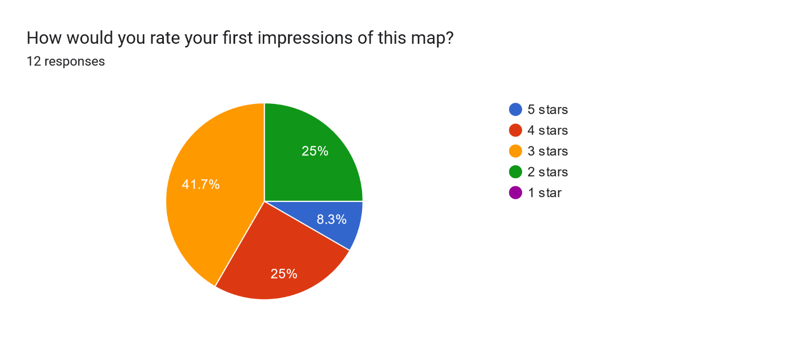 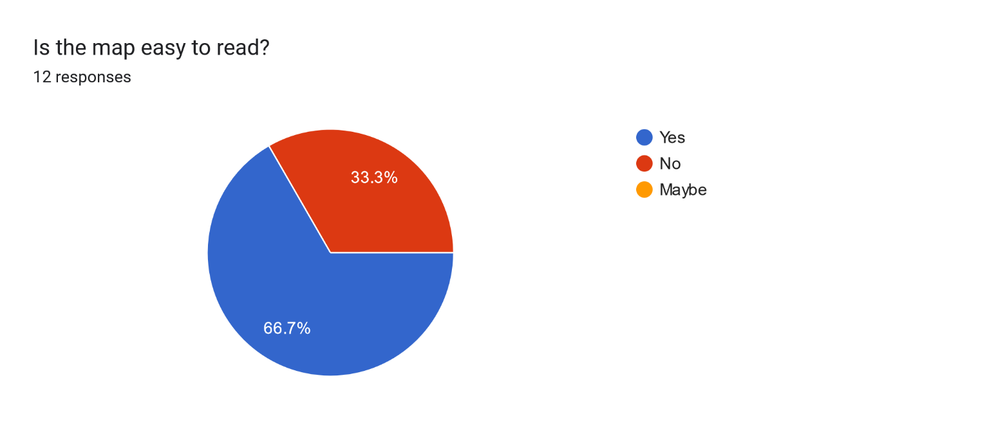

Forms response chart. Question title: Does the different room types (e.g. classroom, toilet, staff room) need to be made clearer?
. Number of responses: 12 responses.

Forms response chart. Question title: Could you find your way around the campus with this map?
. Number of responses: 12 responses.

Forms response chart. Question title: Are you happy with the colour scheme?
. Number of responses: 12 responses.

Forms response chart. Question title: Would you like to see changes to this map?
. Number of responses: 12 responses.

# Appendix B: Notes from weekly supervisor sessions

**Week One: 12th January**

|  |  |
| --- | --- |
| **In Attendance** | JK and RK |
| **Work Presented** | Kanban chart of this weeks to do list. |
| **Supervisor Comments** | * Many of the tasks set by RK were not the priority yet. Focus should be solely on the navigation algorithm as it’s the bedrock of the project. * Suggested splitting the team into two, competing to come up with a basic working algorithm. Then the results could be compared and contrasted to build the best solution. |
| **Outcome** | * Unnecessary tasks removed from Kanban. * The group was split girls v boys. Absent members notified of the new task |

**Week Two: 19th January**

|  |  |
| --- | --- |
| **In Attendance** | JK and RK |
| **Work Presented** | One algorithm (untested) presented, no algorithm from MM and MS |
| **Supervisor Comments** | * Pleased with progress so far * Testing the algorithm would be a good next step * Discussed how the wayfinding will actually work (will rooms be linked by their neighbours, will there be central points dotted around campus..) * Now would be a good time to start on the UI |
| **Outcome** | * JK will start on the UI * RK will test the algorithm * MS will research and formulate a set of suitable tests for the website JK is building * (No contact yet from MM so no task set) |

**Week Three: 26th January**

|  |  |
| --- | --- |
| **In Attendance** | RK |
| **Work Presented** | Progress made testing the A* algorithm. The console hangs when console logs are run. |
| **Supervisor Comments** | * Try more verbose console logging, seeing what exactly is happening at each step could make it clear where the error(s) is. * Make the console log output easier it read, it’s not entirely clear what each value means. * Perhaps split it if statement that adds nodes to the open set to make readability even easier. |
| **Outcome** | * RK will continue work on testing the code. * JK will continue working on the website. * MS hasn’t given an update so assume will continue working on the web testing checklist. * (No contact yet from MM so no task set) |

**Week Four: 2nd February**

|  |  |
| --- | --- |
| **In Attendance** | JK and RK |
| **Work Presented** | * The A* algorithm now works with dummy data. * JSON data has been refined but not yet linked with algorithm. * The website is coming along but the hi-fi prototypes made last term were not specific enough |
| **Supervisor Comments** | * Explained A* algorithms generally include a cost matrix to make it more expensive to go backwards. Ours does not do that but it could be worth making that happen. * Once the algorithm and JSON data is interacting well, the next step is to go from 2D to 3D by adding floors. This is important as the algorithm needs to select the best staircase. * We should aim to get the website, algorithm, and JSON DB all talking to each other by Wednesday (first MVP). * MM and MS continued absence from these sessions were noted. |
| **Outcome** | * RK will get the algorithm to use the JSON file. * JK will complete a basic build of the website to allow input (start and finish points) and output (the suggested route) * Once (if) this is done, both will work on combining the result. * RK to notify MM and MS through the group MS Teams chat that their absence has been noticed and they need to be there next week. * MS hasn’t given update on given task so no new task can be assigned. * MM given task to create ground floor map |

**Week Five: 9th February**

|  |  |
| --- | --- |
| **In Attendance** | JK, MS, and RK |
| **Work Presented** | * RK made little progress with her task. The JavaScript code can print the contents of the JSON file but the web code cannot. * JK’s website has a search function but cannot accept input from algorithm yet |
| **Supervisor Comments** | * Discussed PHP and how it could help parsing data back and forth between the algorithm and the website. * Recommends sorting out the inputs and output of the website. We need to think about how the UI interacts with the back end. * Not sure about having the search function on the website, doesn’t seem to correspond with how the work has progressed. * During reading week we need to focus on getting the component parts talking to each other and improving the design of the site so we have a MVP. |
| **Outcome** | * RK will continue trying to get the algorithm to create a route using the JSON data. Once complete will move on to getting some interaction with the website. * JK will work on the design of the website, focussing on the inputs and outputs that will correspond with the variables and data it will work with. * MS hasn’t given an update on task set on 19th Jan, but additional task given to research QR codes: how to get them and how to integrate them with code written so far. * MM no updates, no task. |

**Week Seven: 1st March**

|  |  |
| --- | --- |
| **In Attendance** | JK and RK |
| **Work Presented** | * RK’s algorithm can grab data from JSON file and output a path to the console. It can also navigate different floors. A PHP file has been created but RK struggling to adjust the JavaScript so it can use the PHP. * JK’s website has a space for a map, but the zoom function isn’t working as intended (the border goes off the screen to the right) |
| **Supervisor Comments** | * Looked at the interaction between the JS, EJS, and PHP files to try to find a bug. Suggests commenting out the if statement to see if the contents of the variables can be printed. If that doesn’t help zip up the code and email to him * Suggested using CSS for the zoom function instead of JavaScript, particularly viewport and transform. |
| **Outcome** | * RK will carry out Sean’s debugging suggestions and send the zip if needed. * JK to look into utilising CSS more for some functions. * No contact from MS since 9th February. Unsure if tasks set have been completed. Nothing new given. * Unsure if MM has completed task given. Nothing new given |

**Week Eight: 8th March**

|  |  |
| --- | --- |
| **In Attendance** | RK |
| **Work Presented** | * RK had emailed Sean the code and has implemented the recommend changes. It is now displaying correctly on a web server. * Report draft was shown |
| **Supervisor Comments** | * Discussed creating a MySQL DB to hold the data instead of JSON. * Only one MVP in the report, suggesting having multiple to allow expansion. * Keep some of the sections on trying to use A* algorithm as it shows use of the double diamond. * Look into SVG for the map. Arrows can be drawn along the route for example. * Suggested some formatting changes to the report itself. * Suggested next tasks: concentrate on the design of the website; each member should write a personal evaluation in the report (what they did, what they learnt, what went well, what didn’t go well) |
| **Outcome** | * RK will continue with report writing; finish off the maps; create MySQL DB * JK to implement some/all of the CSS that Sean included in his email to us. * MM and MS, no contact in the Teams group. No new tasks. * RK to complete QR code task |

**Week Nine: 15th March**

|  |  |
| --- | --- |
| **In Attendance** | RK and JK |
| **Work Presented** | * Report draft. |
| **Supervisor Comments** | * More references, market research, and literature review needed. * Reduce number of screenshots of code. * Some quotes a little long * A bit more writing about the technical elements and design considerations |
| **Outcome** | * RK and JK tasks are the above bullet points. * RK will also continue with the MySQL implementation. * JK will also continue with the web UI. |

# Appendix C: Git Commit History

Figure 46: GitHub contributors and commit history throughout the project.

# Appendix D: User Guide

Scan the QR code at the main entrance to the building:

This will open this link, with the drop-down box prefilled with ‘Main Entrance’:

Select your destination from the choices available:

Follow the route by following the rooms listed until you reach your destination:

# Screens screenshot of a phone Description automatically generatedAppendix E: Kanban

Figure 47: Kanban from 02/02/2024.

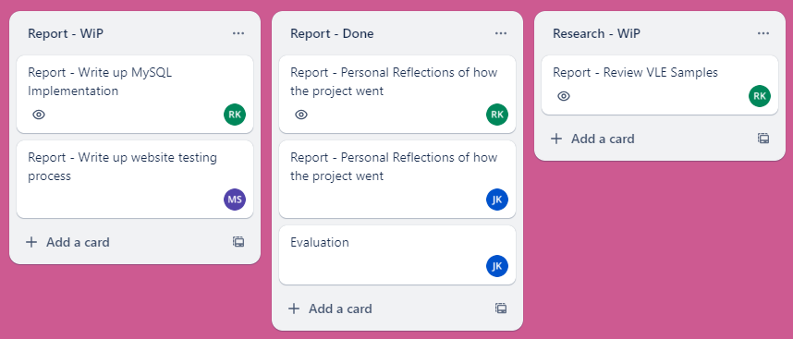

Figure 48: A potentially better way of formatting Kanban.

# Appendix F: UML from previous deliverable

Figure 49:Sequence Diagram explaining how the website was planned to run.

1. https://www.gold.ac.uk/campus-map/rhb-room-finder/
2. [Adobe QR Code Generator](https://new.express.adobe.com/tools/generate-qr-code)
3. https://colourcontrast.cc/
4. https://validator.w3.org/nu/
5. http://www.responsinator.com/